# Feedback on BDC Mockup

Thursday, April 25, 2019

## Shell

As you know, the target resolution is 1440 x 900. I took the latest mockup over to my laptop with a 1680 x 1050 pixel display, essentially 85.7% of my screen in both height and width. Here you see what this looks like, and what is the foundation for most of the feedback that follows:

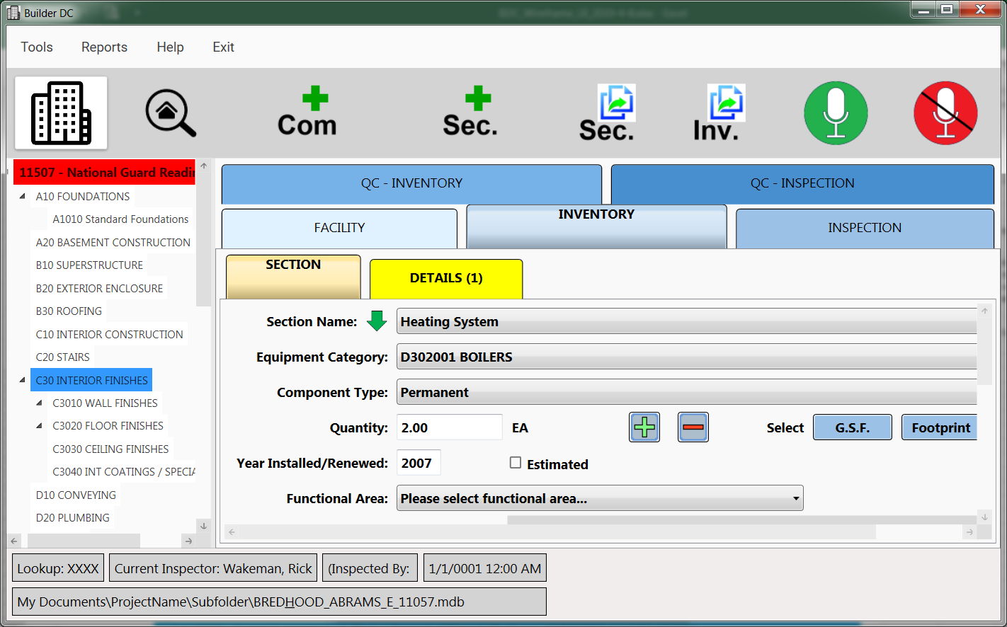

### Menu

* Is it possible to increase font size a bit (for balance with fonts elsewhere)?
* Reports item:
  + InspectionComment Summary -> Inspection Summary
  + QC Reports -> QC Report

### Tree Navigation

* Please change selected node highlighting to
  + Bold
  + Bright Yellow Background with black text (currently it is blue which does not have enough contrast with the blue text in brighter field conditions)
* Please increase the font size of the nodes just a bit. (for more balance with font sizes elsewhere)

## Toolbar

* Can we make the space gaps between the icons smaller?
  + Especially noticeable between Inspection mode icon, Add Component, Add Section nodes.
* Can we also reduce the top and bottom spacing between the gray toolbar background and the icons just a bit?
* For Microphone icons: please give same treatment as you did for Inventory Mode <-> Inspection Mode set so it is clear what mode the user is in. By default of course the Microphone Off should be highlighted (with the white background)

## Status Bar(s)

* Can you keep the left padding but half the top & bottom spacing of the two rows?
* Can you within the text cells, reduce the top and bottom margins such that lowercase letters like p and y still don’t touch the bottom line?

## Tabs, in general

* As you can see, the tabs wrap at 1440 width, not desirable as vertical space is at a premium. Can you set the tabs to not auto width resize but to have fixed widths based on the longest label, QC - INVENTORY while still retaining the space gap between them?
* Please reduce Tab heights by about 20%; still plenty big to tap.
* Change the background color of the DETAILS(1) tab to light green please? (bright yellow as it is I want to reserve for aspects that need to call out attention)

## Facility Tab

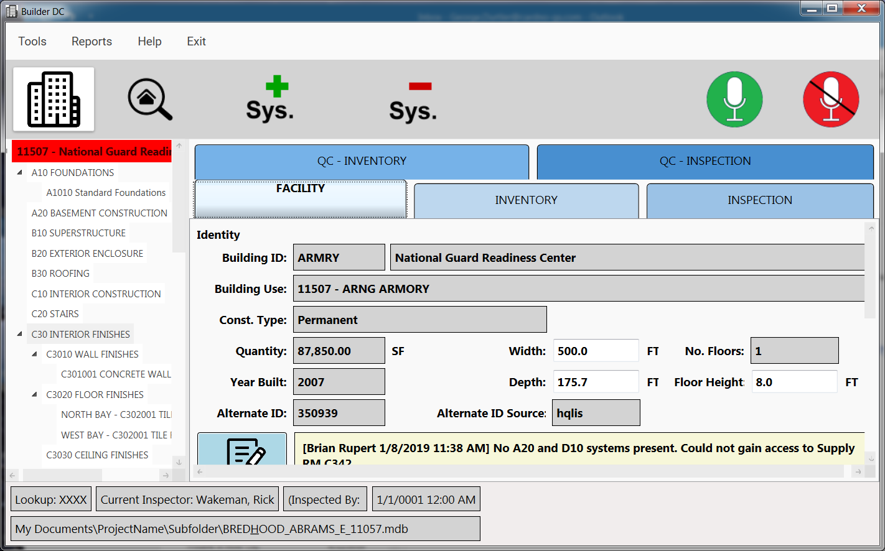

* At the target resolution, we see clipping on the right side. Can we make the cell where National Guard Service center is a bit less wide?
* Same for Building use
* Same for Facility Comment cell width
* Facility Comment cell spacing above text below the cell line can be halved I think.
* Facility Comment cell height can be reduced so that it shows 4 rows of text (1 for auto stamp, then 3 lines for actual comment).
* Can you please add a carriage return after the stamp, delete the second stamp and then have 4 lines of text (of which three show)?
  + Means that the Facility Comment gets reduced in height a bit as well.
* Facility Photos (caroussel) cell can have a bit less padding between edges and photos.
  + Means the Photos button gets reduced a bit in height; Fine
* Can we duce the padding in text cells to have less unused space above and below the text? Example:
  +  to be more like

**ARMRY**

## Inventory Tab

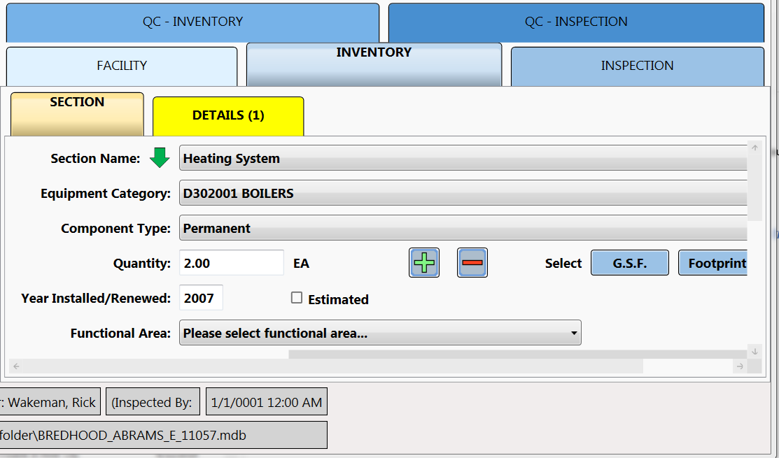

* Reduce width of pull down lists a bit
* Bring the + and - buttons closer to EA (i.e reduce space between EA and + by about 2/3.
* That allows the **Select** label to come closer to the left, as well as GSF, Footprint and Perimeter
* Can we close the gap between the Year Installed/Renewed text cell and the Estimated checkbox to be reduced?
* The line of Functional Area can be commented out or deleted, not needed.

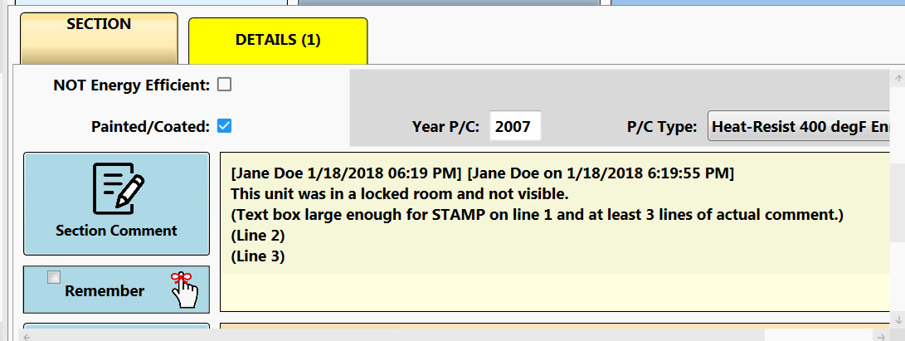

* Section comment area is taller than needs to be, but not sure how to handle because of the Remember function. We only need to see 4 lines (1: auto stamp and 3 for comment). We allow about 6 - 7 currently in the mock up.  
  Suggestion?

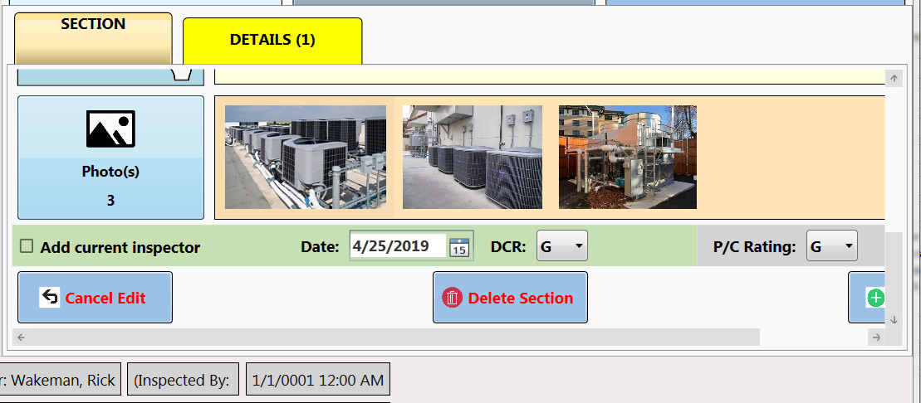

* Photos section: See comment for Facility tab
* Wrong label: Add current inspector -> Add current inspection
* DCR and P/C Rating pulldown lists: Yellow is actually amber. In original application Amber is used, so please delete from both: Y+, Y and Y. There are exactly nine possible ratings.
* Cancel Edit button: Black text would be more appropriate
* Can you reduce the space between the three bottom buttons by about half, so Add Section button is fully visible even at this width (without scrolling)? (p.s.: This button does the same thing as the Sec.+ button in toolbar.

## DETAILS Tab

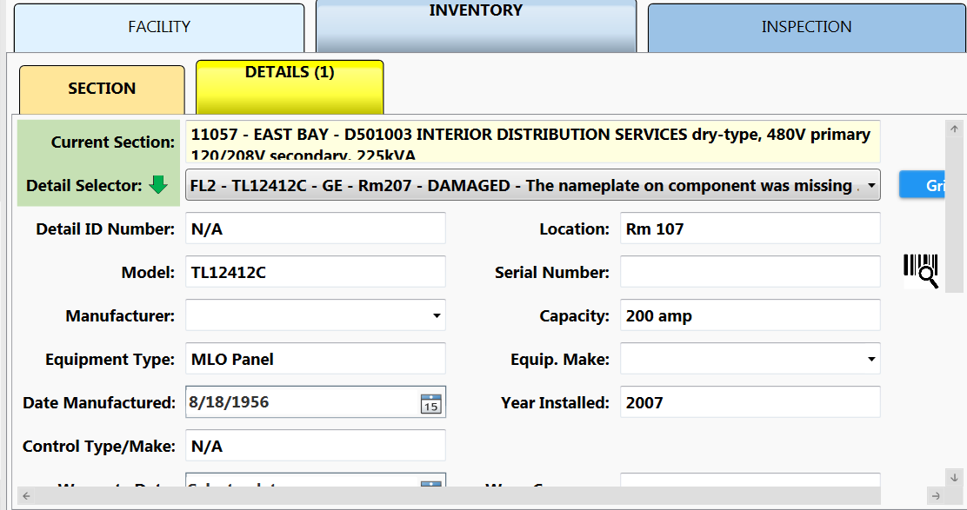

* Current Selection text box will likely show the wrap around line OK if we tighten up the top padding between text and the cell boundary.
* Same feedback for Comment text box as for Facility Tab. (Please add line break after auto stamp to represent what users will see.)
* Cancel Edit button: in black text would be better.

## Inspection Tab

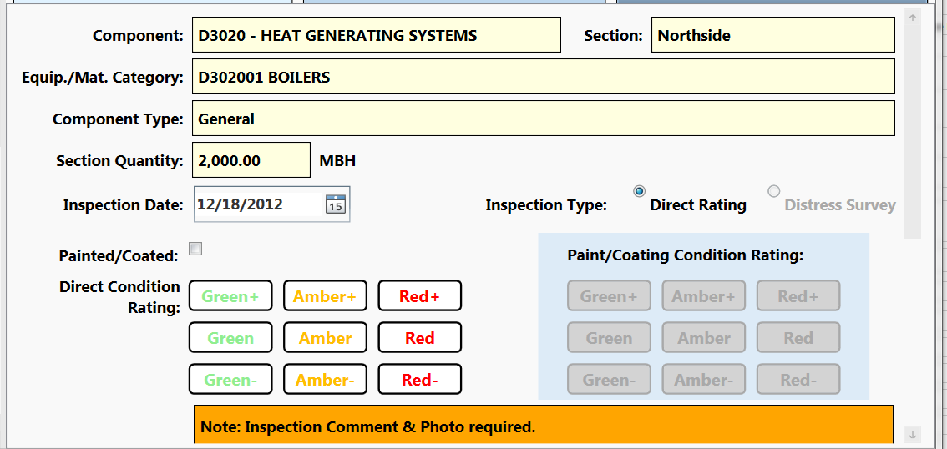

* Can you inline the radio buttons for Direct Rating and (disabled) Distress Survey with the labels?
* For the Green buttons, can you use a dark Green and for Amber also a darker shade?
* Inspection comment similar to prev feedback.
* Same for photos
* Cancel Edit text in black font

## QC- INVENTORY Tab

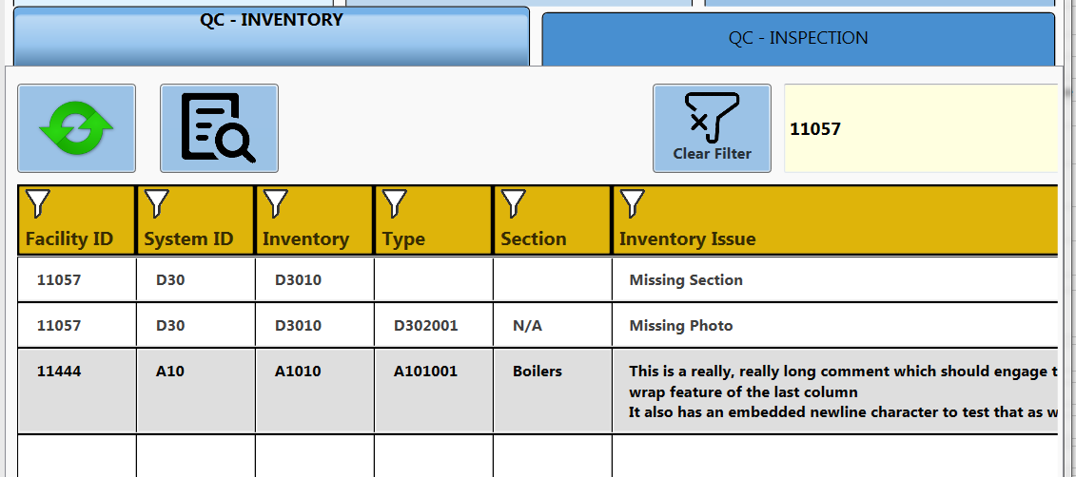

* For Inspectors the important thing to read are the listed issues, so I want to tighten up the column widths as follows:
  + All cells : half the leading padding
  + Facility ID -> Fac. ID (need room for 6 digits, though typically 5)
  + System ID -> System ALWAYS 1 letter and 2 #s in width
  + Inventory -> Comp. (= Component, users know this) ALWAYS 1 letter and 4 #s.
  + Type: ALWAYS 1 letter and 6 #s
* I think we can bring the "Clear filter" button over to the left along with the filter text box
* The contrast of the selected item is still not enough; please try changing the light gray to medium-bright yellow? (or how about we inverse the selection: Background dark gray and text in white?

## QC-INSPECTION Tab

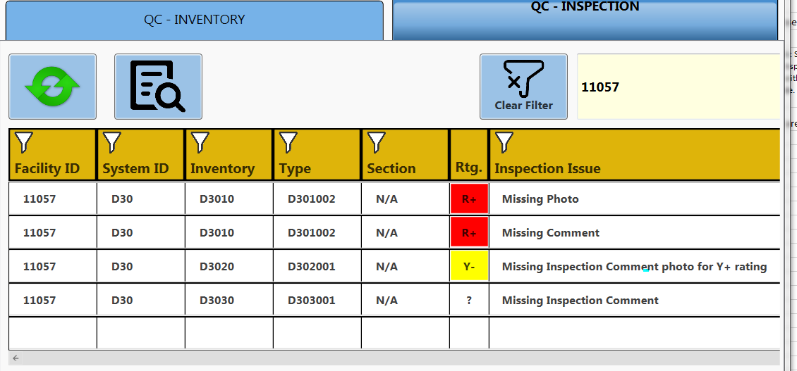

* Same feedback as given for other QC Tab.
* Rtg. Column header -> DCR (which users know stands for Direct Condition Rating)
* In the sample, please change the Y- value to A- to be consistent. (so whenever I say or write Yellow for rating I actually mean to say Amber. Sorry I am inconsistent, it is because I manage another system where Amber is known as Yellow…means the same thing)

## Facility Comments UI

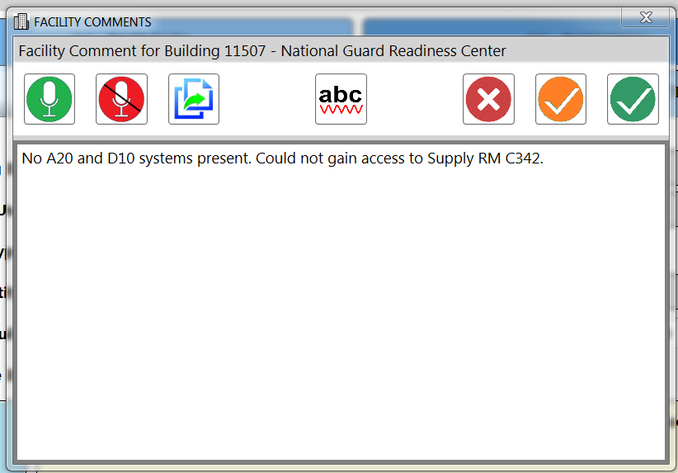

* Microphone icons are a pair; needs to be clear which one is chosen. By default, Off. What do you think? Should we switch to only showing the green ON one when off , and only the red one when listening?
* Window title to change to singular: FACILITY COMMENT
* Just realized: We need BOTH a Cancel Edits button AND a delete button. In my wireframe, I showed just the Cancel edit icon. 
  + Can you add the Cancel edit icon ?
  + Can you replace the  with the garbage can symbol you have used elsewhere to be consistent?

## COPY INVENTORY UI

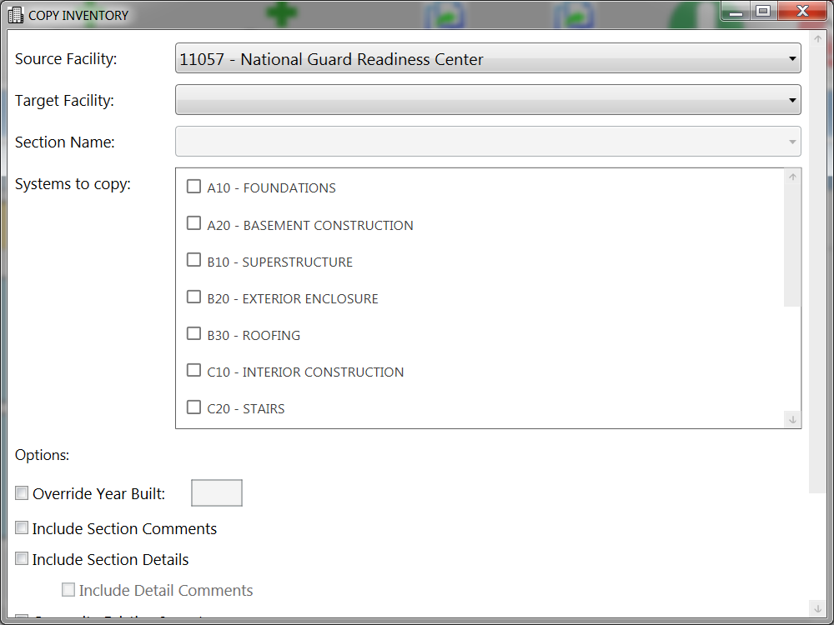

* It is important that the user should not have to scroll this window, everything needs to appear down to the buttons. Suggestions to do that:
  + The Systems to copy section can be reduced to four lines down from seven you have now. After all it does scroll and most users will only see less than 5 anyway (because in PT stage the available options will be reduced to just those they are assigned to)
  + We can bring over last three to the right side perhaps, like this:

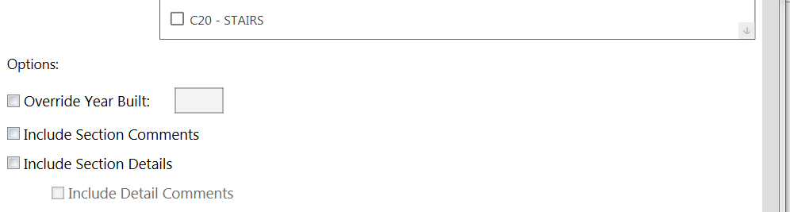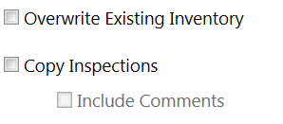



* + Please change Include Comments under Copy Inspections to Include Inspection Comments (for absolute clarity, as there are different types of comments)